Are You Interested in Selling Your Property?

Dear CAPITOL SQUARE LP,

Do you have any other multifamily properties that you are interested in selling similar to
4000, 4003 & 4011 38th St, Brentwood, MD 20722?

As a property owner, I realize that there are a number of reasons why someone may be interested in selling:
- CashFlow Issues
- Payback Investors
- 1031 Exchange
- Retirement
- Move on to another investment
I'm not an agent, so I'm not interested in listing your property but in buying it directly.

If you're interested in selling your property now or in a few months (or are just curious how much your property is worth), please give me a call at 202-643-9566 or email me at trevor.finn1@gmail.com to discuss.

Thanks, and I look forward to hearing from you.

Kind regards,

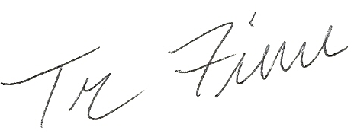

Trevor Finn
https://www.linkedin.com/in/trevorfinn/

P.S. To get the best price for your property, please call me now at 202-643-9566.

